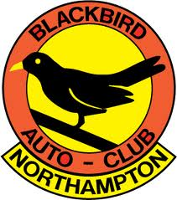
Blackbird Auto Club
Membership Application/Renewal Form
Name:

Address:

Home Phone No: Mobile Phone No:

Email:

Next of Kin:

Address:

Home Phone No: Mobile Phone No:

Email:
The BBAC is an officially recognised MSA Club and is an associate member of the East Midlands Association of Motor Clubs EMAMC. As a member of the BBAC you agree to be bound fully by the rules of those governing bodies and any/all ancillary/supplemental rules of the BBAC.
Junior Members: Must be 12 years of age or over with a parent or guardian who is also a BBAC member.
Club Newsletter The BBAC produces a periodic edition which is distributed solely by email.
Membership payment: £10 covering a single individual membership until the BBAC Club AGM in 2023.
Membership Secretary: Richard Drydale
Electronic Payment: Account No: 70079421 Sort code: 20-61-51
Please use payment reference MEMBERSHIP followed by your surname, then email this form to info@blackbirdautoclub.co.uk Membership will then be confirmed upon proof of payment.
Data Protection Note: Your information will be held on computer but WILL NOT be divulged or sold on to any other sources

